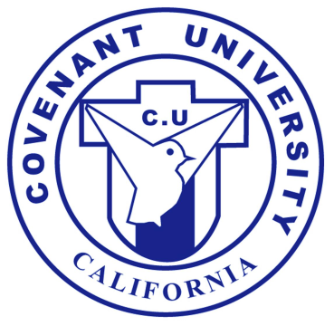

Admission Requirements 지원자격 및 제출서류

B

achelor’s Program: 학사 과정

Applicants desiring entrance into the Bachelor's degree program must have completed the requirements for a high school diploma or equivalent. Four years seminary graduated students are accepted as a transfer student. 고등학교 졸업자. 4년제 신학대학 졸업자는 편입생으로 입학 가능.

Required documents and fee 제출서류 및 지원료

1. Application Form I and II: an application is valid for one year. 입학지원서I, II
2. Personal Statement (in 250 words or more) describing reasons for wanting to study with confession of faith. 신앙고백이 담긴 학위취득사유서 (250자 이상)
3. Official transcripts of all academic work undertaken from high school. 고등학교 성적증명서
4. Application Fee ($50) 입학지원료 50불

M

aster’s Program: 석사 과정

All Master's programs require satisfactory completion of a Bachelor's degree or its equivalent. Th.M. requires M.Div. or its equivalent. One who has B.A. and finished research project is accepted as a transfer student. 학사학위이상 소지자. Th.M.과정은 M.Div 학위 또는 그에 준하는 학위 소지자.

타 석사과정 수료자는 편입생으로 입학 가능.

Required documents and fee제출서류 및 지원료

1. Application Form I and II: an application is valid for one year. 입학지원서I, II
2. Personal Statement (in 250 words or more) describing reasons for wanting to study with confession of faith. 신앙고백이 담긴 학위취득사유서 (250자 이상)
3. Official transcripts of all academic work undertaken since graduation from high school. A final official transcript indicating that the bachelor's degree or its equivalent has been granted should be submitted. 학사학위 성적증명서
4. Application Fee ($50) 입학지원료 50불

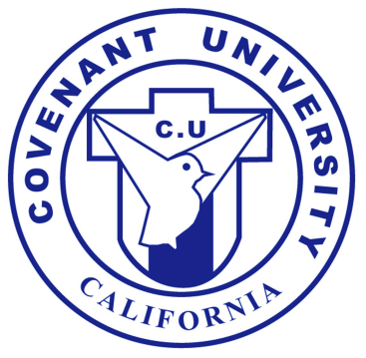

D

octoral Program: 박사 과정

Doctor of Theology (Th.D.): This program requires satisfactory completion of a M.Div. and Th.M. degrees or its equivalent. 신학 박사과정은 M.Div와 Th.M 또는 그에 준하는 학위 소지자.

Doctor of Ministry (D.Min.): This program requires satisfactory completion of a M.Div. and Th.M. degrees or its equivalent with pastoral career. 목회학 박사과정은 목회경력 및 M.Div와 Th.D학위 또는 그에 준하는 학위 소지자.

All other doctoral programs (Doctor of Missiology, Doctor of Christian Counseling, Doctor of Christian Education, Doctor of Religion, Doctor of Religious Art, Doctor of Religious Social Welfare, Doctor of Religious Philosophy, Doctor of Healing Ministry, and Doctor of Church Music, and Doctor of Sports Mission) require satisfactory completion of a M.A. or its equivalent. 기타 모든 박사과정은 일반 석사학위 또는 그에 준하는 학위 소지자.

Required documents and fee 제출서류 및 지원료

1. Application Form I and II: an application is valid for one year. 입학지원서I, II.
2. Personal Statement (in 250 words or more) describing reasons for wanting to study with confession of faith 신앙고백이 담긴 학위취득사유서 (250자 이상)
3. Resume 이력서
4. Official transcripts of all academic work undertaken since graduation from high school. A final official transcript indicating that the applicable master's degree or its equivalent has been granted should be submitted. 학사 및 석사학위 성적증명서
5. Application Fee ($50) 입학지원료 50불