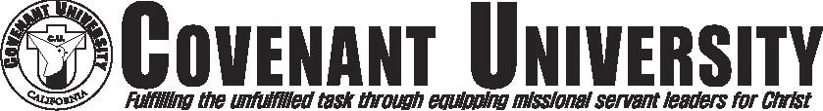

**English Language Proficiency Verification**

## Student’s Name:

**Student’s ID No.**:

**Student’s Date of Birth**:

All students attending Covenant University must prove their English ability to show that they are qualified to study the courses provided by Covenant University which are taught in English.

If you meet one of the standards listed below, please mark the box and submit this form along with

***valid supporting document*** (Unofficial copy of the document will not be accepted).

The student has taken the TOEFL and has received a score of 60 or above and can provide the school with a report of their score.

The student has previously completed a highest level of ESL course at another institution prior to studying at CU and can provide the school with a transcript or a certificate of achievement.

The student has previously taken any level of English class at another institution with a letter grade of “C” or better in a U.S. institution and can provide the school with a transcript.

If you do not meet any of the above standards, please choose among the following options to meet the English language proficiency requirement:

I will take placement exam in Covenant University to verify my English language proficiency.

I do not wish to take placement exam but want to take the beginning level of English language development class.

|  |
| --- |
| OFFICE USE ONLY |
| English Prep Course Waived Y( ) N( ) Approved by: |
| Document Provided: TOEFL Transcript Certificate |
| Placement Exam Score: Level Enrolled: |

# I hereby agree and will comply with the Covenant University’s English language proficiency placement policy.

Signature Date

REVISED 11/24/2014